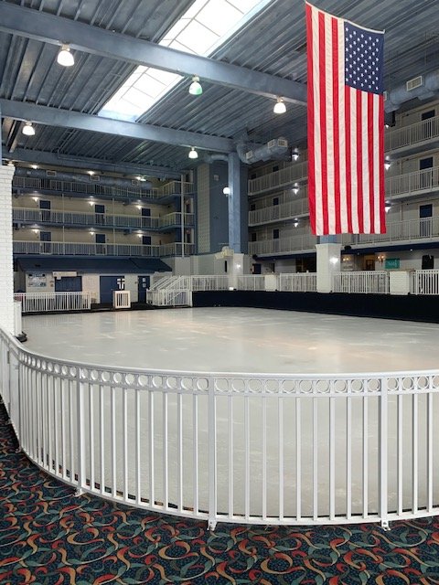
The Carousel Ice Rink will be closed for annual conferences:
March 22, 2026 – April 2, 2026
April 6, 2026 – April 17, 2026
September 13, 2026 – September 24, 2026

The Carousel Ice Rink will have very limited hours due to a Hockey Tournament and may not open at all:
January 23, 2026 – January 25, 2026
January 30, 2026 – February 1, 2026
February 6, 2026 – February 8, 2026
February 20, 2026 – February 22, 2026
February 27, 2026 – March 1, 2026
March 6, 2026 – March 8, 2026
October 24, 2026 – October 26, 2026
November 13, 2026 – November 15, 2026
If there are any changes to this schedule, I will let you know as soon as possible.
We apologize for any inconvenience.

