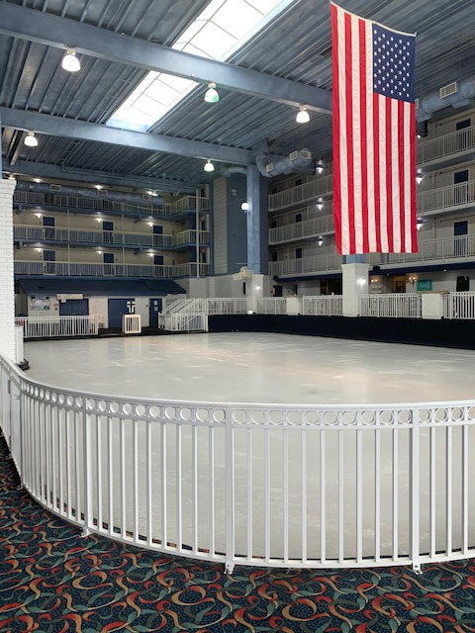
The Carousel Ice Rink will be closed during the following dates:
March 16, 2025 – April 19, 2025
April 20, 2025 – May 3, 2025 (Tentative)
September 6, 2025 – September 20, 2025
The Carousel Ice Rink MAY be open with extremely limited hours (If open at all) during the following dates:
January 24, 2025– January 26, 2025
January 31, 2025 – February 2, 2025
February 7, 2025 – February 9, 2025
February 21, 2025 – February 23, 2025
February 28, 2025 – March 2, 2025
March 7, 2025 – March 9, 2025
October 24, 2025 – October 26, 2025
October 31, 2025 – November 2, 2025 (Tentative)

