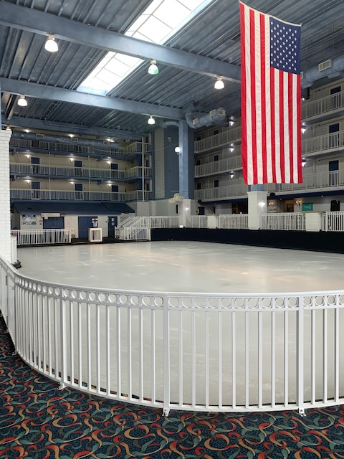
The Carousel Ice Rink will be closed during the following dates:
Sunday April 9, 2023 – Thursday April 20, 2023.
The Carousel Hotel will be hosting The Ocean Renaissance Seafarer’s Carnival from April 14 – April 16 and the ice rink will be used for exhibition space as well as lots of fun activities.
The Ice Rink will re-open on Friday April 21, 2023 at 4:00pm.
We apologize for any inconvenience.
Please feel free to reach out with any questions or concerns.
Thank you!
Cheryl

