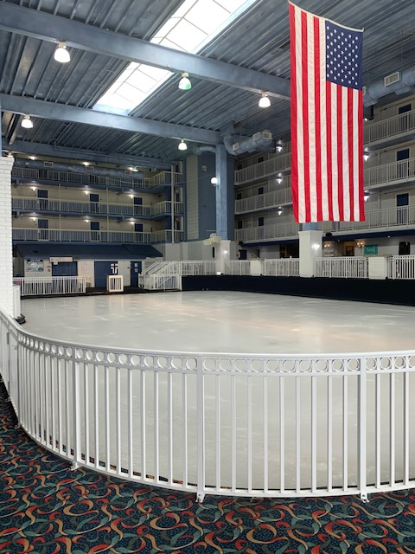
The Carousel Ice Rink will be closed during the following dates:
Sunday February 5, 2023 – Saturday February 11, 2023.
In addition – the price of Ice Skating will increase beginning Friday January 20, 2023:
Condo owners and their guests AND hotel guests who bring their own skates - $6.00
Condo owners and their guests AND hotel guests who do not bring their own skates: $10.00
Non guests of the hotel who bring their own skates - $8.00
Non guests of the hotel who do not bring their own skates: $14.00
Please feel free to reach out with any questions or concerns.
Thank you!
Cheryl

